ANISH ASHOK ANKALGI
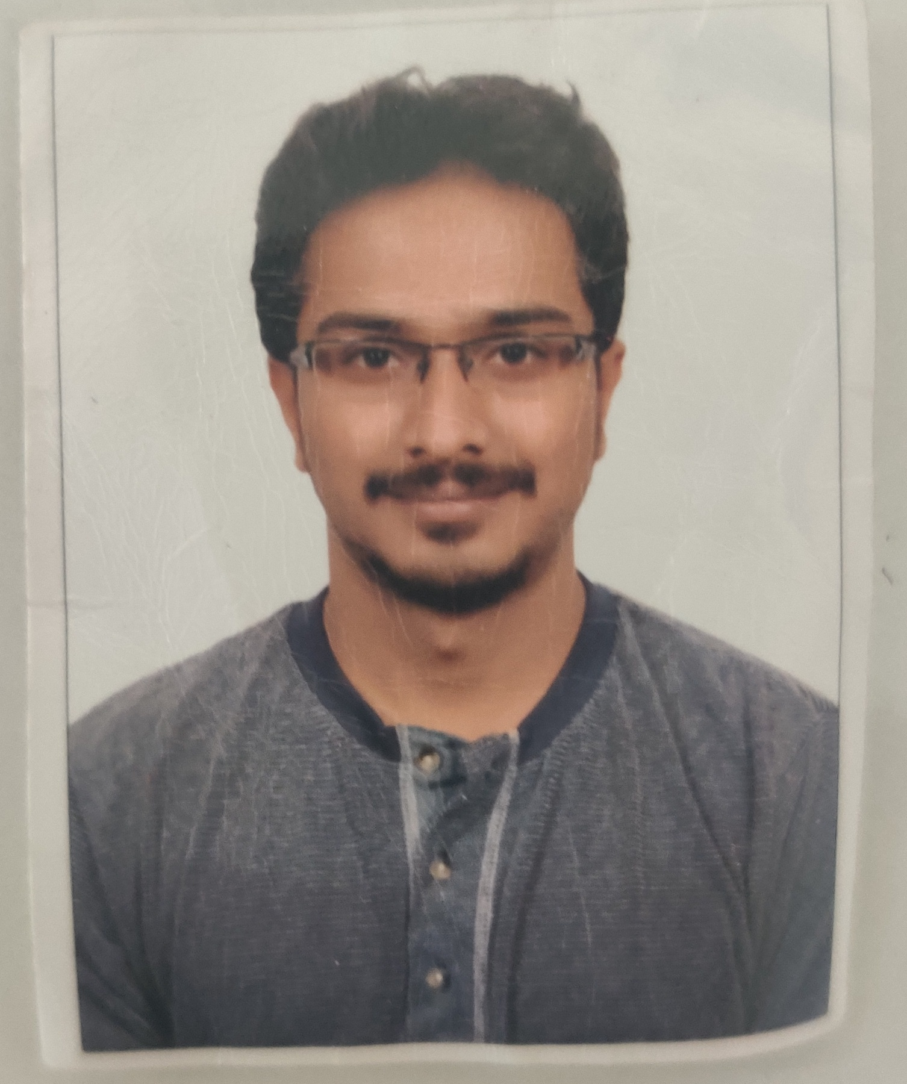

Bangalore, India﻿
Mobile: +91 9008241839
E-Mail: anishaddi1992@gmail.com
LinkedIn: Anish Ankalgi
Passport Number: J7067545

Personal Particulars
Permanent Address: #12, Sai Amogh Royal Enclave, Phase 2, Sriramapura, Amruthalli,
Bangalore – 64
Nationality: Indian | Gender: Male | Date of Birth: 10-05-1992 | Marital Status: Married

SUMMARY

- Astute and accomplished professional with 5+ years of domain expertise in Corporate Human Resources, Consumer and Community Banking Claims, Asset Management, Sales and Trading, and other Investor Management services
- Adroit in consumer and business banking services which encompasses wealth management, mortgage banking, and card services
- Adept at key controls in HR processes including Operational Risk Management, Recruiting/Hiring, Employee Management and developing Root cause analysis to evaluate and implement potential solutions
- Demonstrated excellence in associating with the management to ensure effectiveness, compliance, and equity within the corporate organization
- Quick learner and also manages any task given and ensure that the work is completed without any errors with 100% quality.

SKILL SET
- Employee Relations & Onboarding  - Training & Development  - Recruiting & Hiring | - Sales /Marketing  - Performance/ Project Management  - Sales Target/achievement | - Microsoft Office  - Business Development  - Conflict Resolution  - Customer Relations

EDUCATION
- Bachelor of Business Management from M S Ramaiah College, Bangalore, India – 2014

WORK EXPERIENCE
Organization | Designation | Duration
JP Morgan Chase and Co., India | Corporate HR (Team Member) | Jul 2018 - current
JP Morgan Chase & Co., India | CCB “Claims Specialist” | Mar 2016 - Jul 2018
Concentrix(IBM), India | Sales Consultant | June 2014 – Oct 2015

As Corporate HR
- Proactive in human resource planning and ensuring in Flawless performance management
- Recruiting the right candidates and involving in the training and development of the candidates
- Providing effective timely career guidance, resolving conflicts and handling rewards framework
- Assuring health and safety in workplace, maintaining a good work culture and overseeing other administrative responsibilities
- Also assisting internal, new employees and external employees with their query about the HR policies about the organization

As CCB Claims Specialist
- Responsible for claims inbound calls and ensuring that customer’s data is safe and working on end to end investigation if fraud occurred in customers account and resolving the issue
- Strategically co -ordinated for claims in extracting business data and ensuring the floor is in disciplined

As a Sales Consultant
- Key role involvement in meeting customers in a sales environment to drive product sales and knowledge
- Demonstrated advanced products knowledge and adhering to all company policies and procedures
- Arranged sales appointments with clients and generating new leads by meeting with consumers
- Followed up with any clients to make sure that they are satisfied with the products
- Assembled all product displays in a given market

Accomplishments
- Awarded with “ Certificate of Excellence ” from Noor Bank for Sales in 2014
- Moved as a Relief Strategy Coordinator in Claims from April 2017 to January 2018
- Awarded with service excellence in HRSD floor for July and November 2019

References will be provided upon request

